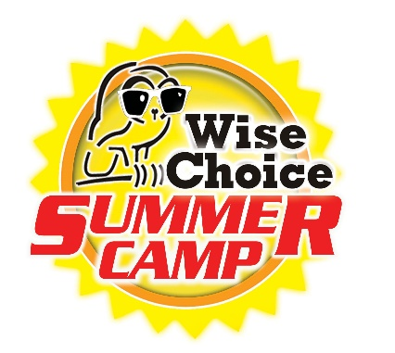
OUR TOP PRIORITY IS TO KEEP YOUR CHILDREN SAFE!

Dear Parents,
First and foremost, we hope that you and your loved ones are safe and healthy. We have received questions from parents about if and how COVID-19 will affect Wise Choice Summer Camp this summer. We know that this pandemic has been stressful to many and recognize that socializing and interacting with peers can be a healthy way for children to cope with stress and connect with others, particularly after spending quite a bit of time at home. After careful thought and planning, we are excited to let you know that we plan to resume camp while following CDC considerations to protect campers, families, and our community.

The health and safety of our campers and staff remain our highest priority. Below, you will find a summary of actions we are taking to help ensure we are lowering COVID-19 risk as much as possible. We are:

- Intensifying cleaning and disinfection practices within our facilities and premises by cleaning and disinfecting frequently touched surfaces (e.g., door handles, light switches, tables, chairs), cleaning and disinfecting objects if they are shared (e.g., art supplies, sports equipment, toys, and games), and ensuring safe and correct use and storage of disinfectants.
- We will be disinfecting and sanitizing all seating and touchpoints areas throughout the day and at the end of each camp day with Vital Oxide, an EPA approved solution, which kills 99.99% of viruses, including Covid-19 (https://vitaloxide.com/). Vital Oxide is an approved disinfectant solution of EPA approved cleaners.
- We will be administering the Vital Oxide solution via misting spray machines or by spray bottle and wipe down method. Our staff will be fully trained on the protocols set forth by Enviro Master, which is an award-winning commercial health and safety company offering sanitation, disinfection, deep-cleaning, and hygienic services, to protect the health of your campers and staff.
- We will provide hand sanitizer stations at all entry points and throughout the facilities (check in area, rooms where campers will be housed, and all areas where campers and staff will be utilizing). We will require all employees entering the facility to hand sanitize upon arrive for their shift and prior to entry.
- We will implement daily screenings for staff and campers consisting of entry temperature checks and CDC health screening questions. We will use a touchless thermometer to check temperature. Persons with body temperatures of greater than 100.4 will be prohibited from entering the facility.
- We will keep campers in small groups and spacing them out as much as possible by prioritizing outdoor activities, and socially distancing seating and gathering areas.
- We will require that all staff and campers wear a facial covering while indoors. While outdoors, we will provide the campers with mask breaks as long as physical distancing is possible. Facial coverings will be required outdoors at times whenever physical distancing is not possible or difficult.
- We will limit the number of items that are shared or touched between campers and staff. We will make every effort to provide individual supplies to each camper, keeping a camper’s belongings separated from others and in individually labeled containers, cubbies, or we will limit use of supplies and equipment to one group of campers at a time and clean and disinfect between use.
- Campers will be required to bring their own lunch and we will provide areas for eating which comply with the recommended CDC social distancing requirements. Staff members will be cleaning and disinfecting tables after lunch. We ask that any and all plates, cups, and flatware, to the extent necessary, be disposable.
- We will promote healthy hygiene practices by teaching campers the importance of washing their hands with soap and water for at least 20 seconds, monitoring campers to make sure they are washing their hands, providing campers with hand sanitizer with at least 60% alcohol when they don’t have easy access to soap and water, encouraging children to cover their coughs and sneezes with a tissue or to use the inside of their elbow, and posting signs about these healthy habits around the camp facility.
- If a child does get sick at camp, we have identified an area where they can rest, be watched after, and safely isolate from others. We will communicate with parents or caretakers directly and, if necessary, arrange for the child to be taken to a healthcare facility for care.
We ask that you help us protect the health of campers this summer. Anyone who is sick or was sick with COVID-19 or recently in contact with someone with COVID-19 in the last 14 days— including staff, campers, and families— should not come to camp. Be on the lookout for symptoms of COVID-19, which include fever, cough, shortness of breath, chills, muscle pain, sore throat, and loss of taste or smell. Call your doctor if you think you or a family member is sick.
If you have a specific question about this plan or COVID-19, please contact your camp director for more information. You can also find more information about COVID-19 at www.cdc.gov/coronavirus or on CDC’s website for youth and summer camps (https://www.cdc.gov/coronavirus/2019-ncov/community/schools-childcare/summer-camps.html).
We look forward to seeing you at camp this summer.

Thank you and stay healthy,

Daniel Yanes, Director
Wise Choice Summer Camp

